**WHEN DID WRITING BEGIN?**

Modern life would be practically impossible without written language. We rely on written next for knowledge, experience and, nowadays, essentially daily basic communication. We take it for granted that humanity and civilization *come* with writing! But this was not always the case. The people who lived in the ancient periods that gave birth to the literary works of this course did not know of writing as we mean it. Both the Sumerian and the ancient Greek culture relied on oral tradition. The epic poems *Gilgamesh* and the *Odyssey* were initially weaved like quilts, their fabric being the memory of the distant past, legendary events, heroes and their deeds interlaced in oral stories that eventually formed the epic poems we recognize today as *Gilgamesh* and the *Odyssey.* It’s not exactly right to say that these poems were *written* for long before their content was finally put together in writing by subsequent generations, they were composed in their creators’ imaginations and delivered orally. But before we get to the poems, we should answer the very basic question that we seldom think about: when did writing really begin?

Writing began over 5000 years ago in the ancient Sumerian civilization, where the epic story of *Gilgamesh* takes place. Most of the early writing systems consisted of small pictures or icons representing words and by combining these pictures one could represent a concept. For instance, if one put a picture of a man with an inverted V over his head, it would mean “home”. These symbols would be drawn on wet clay and when the clay hardened it could be carried to others who could interpret its meaning. This first writing was called “cuneiform.”

About a century later, the Egyptians began to develop writing using a similar but different system of pictures representing words.  This Egyptian system is called “hieroglyphs” and these symbols were most often written on a type of paper called papyrus using a fine reed point and ink. (These symbols were a mystery to modern generations until the discovery of the Rosetta stone about 200 years ago).

In China, about 3500 years ago, this early civilization formed their own form of writing. This form of writing has thousands of characters, but it has survived to today—even though it is not easy to print, and difficult to use in word processing.

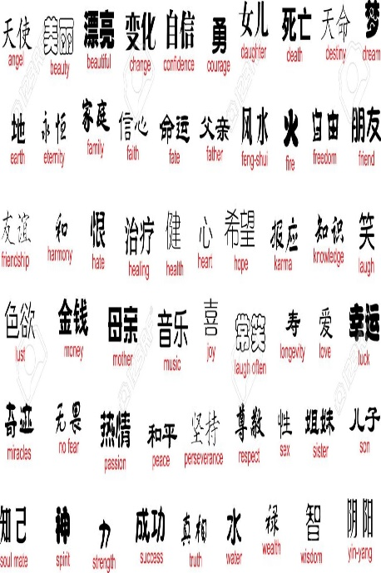

Then, about 2000 years ago, writing began to move from a pictorial representation of words to an alphabetic representation that contained consonants and vowels that could be put together in different combinations and interpreted by a reader as a word.  Words could be grouped into sentences; sentences into paragraphs. This alphabetic system simplified and standardized writing and soon became a part of everyday life. Recorded history emerged in the classical period (circa 4th century BC) as a result of this development.

There are various types of writing. For the purposes of this course we should focus on the following:

**EXSPOSITORY WRITING**

**Expository writing** is a type of **writing** that is used to explain, describe, give information, define or inform. The text is organized around one topic and developed according to a pattern or combination of patterns. Expository essays are written by students to demonstrate their understanding of a particular subject.

 There are different types of expository essays:

* **The how-to or process essay (such as How to Build a Bird House)**
* **The descriptive essay (such as My Favorite Summer Vacation)**
* **The cause and effect essay (such as What were the Causes of the Civil War)**

The How-To essay is a step-by step guide on the steps taken to do something. It must be detailed enough so the reader has all the information needed to complete the task.

The Descriptive essay describes something in detail. The writer must paint a picture using words so the reader can create a picture in his mind. You can use creative vocabulary with metaphors and similes to create the most vivid picture possible.

The Cause and Effect essay explains how certain actions caused a reaction or effect. It explains why something turned out the way it is, or how one thing leads to another.

An Expository essay does exactly what its names implies: it exposes. It is all about facts—without giving a personal opinion or taking a side. It is structured like other types of essays, with an introductory paragraph that contains a thesis statement, and a main body of paragraphs the prove the thesis statement. It also has a conclusive paragraph.

**DESCRIPTIVE WRITING**

The primary purpose of **descriptive writing** is to describe a person, place or thing in such a way that a picture is formed in the reader's mind. Capturing an event through **descriptive writing**involves paying close attention to the details by using all of your five senses.

Here are some hints for creative descriptive essays:

* **Look for examples for descriptive writing—literature is full of them.**
* **Use interesting, descriptive word choices.**
* **Good descriptive writing includes many vivid sensory details that paint a picture and appeals to all of the reader's senses of sight, hearing, touch, smell and taste when appropriate. Descriptive writing may also paint pictures of the feelings the person, place or thing invokes in the writer.**
* **Good descriptive writing incorporates figurative language: similes, metaphors, idioms, imagery help paint the picture in the reader's mind. (Check the entire list of figurative language types in *Effective Reading, Readable Writing*, p.p. 6-7.)**
* **Good descriptive writing uses precise language. General adjectives, nouns, and passive verbs do not have a place in good descriptive writing. Use specific adjectives and nouns and strong action verbs to give life to the picture you are painting in the reader's mind.**
* **Good descriptive writing is organized. Some ways to organize descriptive writing include: chronological (time), spatial (location), and order of importance. When describing a person, you might begin with a physical description, followed by how that person thinks, feels and acts.**

Remember, the more descriptive words you use, the clearer you will create a picture in the reader’s mind.

**REFLECTIVE WRITING**

Criticism is an example of reflective writing. A critic observes a work of art, sees a film, or reads a book and offers her opinion about it based upon a subjective impression, which nevertheless is based upon a certain knowledge and expertise the writer possesses on the specific field, style or time period the work belongs to. A well informed reader of the *Odyssey*, for example, writes a reflection on a certain event, conflict or character emerging from Homer’s poem. Students tend to write a lot of reflective papers in which they present their impressions of a given work based upon a knowledge acquired in the course. Successful reflections often include comparative perspectives and analysis.

**PERSUASIVE WRITING**

Do you want to convince others to agree with your opinion about something? Write a persuasive or argumentative essay. A persuasive essay is intended to persuade readers to accept or reject an idea or point of view. However, an [argumentative essay](https://literarydevices.net/argumentative-essay/) intends to make readers see both sides of the coin so they can decide on their own about the credibility of an idea. It is up to them to select any of the two. In other words, an argumentative essay presents both arguments; both for and against an idea and leaves the readers to decide. On the other hand, a persuasive essay intends to urge readers to see things a certain way. Therefore, it presents arguments only about one aspect of the issue.

To present a persuasive argument you must first:

* **Do some research for facts to back up an opinion.**
* **Clearly summarize your point of view based on .**

Persuasive/argumentative writing is a good way to tell people about your thoughts on certain subjects.

NARRATIVE

A **narrative** essay is a story written about a personal experience. **Writing** a **narrative** essay provides an opportunity to get to know and understand yourself better. One of the best ways to reveal who you are is to **write** about how you became aware of something, gained a new way of seeing the world, a new insight.

As also explained in *Effective Reading, Readable Writing,* usually, narrative writing is associated with **fiction**, which is based on imaginative events or stories that did not actually happen. The other category of writing is known as **nonfiction**, which would be writing that is based on real facts. This usually consists of newspapers, essays, reports, and other informative writing. However, some nonfiction can in fact tell a story, which would classify it as narrative writing. In the case of nonfiction, the story must be a true story with real people and events, such as an autobiography, a biography or a memoir. All narrative stories have:

* **Characters – Real or fictional people**
* **Plot – events that occur in the story**
* **Conflict – A struggle that takes place between people of events—a problem**
* **Setting – Time and location where the story takes place**
* **Point of view - Either it is told by a character or a narrator**

**POETIC WRITING**

Literature begins with poetry. In antiquity, reciting poetry was a popular form of entertainment. In ancient Greece **bards** (poets who recited poetry musically sometimes accompanied by a musical instrument called lyre) like Homer were popular figures. Their art of remembering, composing and delivering tales that incorporated imaginary and real events and characters gave them power and fame. Due to lack of books ancient people relied on oral tales for knowledge and entertainment. Literary works written in prose as we know them today (fiction or nonfiction, such as novels, biographies etc.) did not exist back then. The most defining literary genre of modernity, the novel, it must be understood, began around the Renaissance (1500s AD). Thus, in the ancient period literature meant poetry.

There are various types of poetry, but the oldest is the Epic Poem, which is the subject matter of this course. Before you immerse into reading *Gilgamesh* and the *Odyssey* we should ponder a very basic question: what makes an epic poem epic? These are some of its main characteristics that by the end of the course you should be able to recognize and understand:

-The distinction between epic poetry and any other poetry begins with length: the epic is a long narrative delivered in verse and elevated language.

-It originates in the oral tradition(s) of ancient civilizations.

-Its origins are in oral tales, legends and myths.

-It springs from the past and it is maintained in people’s memory.

-It begins with an invocation to the muse. (In which case we should examine the role, as well as the profile of a muse.) Check the first two lines of the *Odyssey* and get to know the muse.

-It is a testimony of an ancient civilization’s values, customs and traditions.

-It provides with insights into ancient civilizations such as the Sumerian, the Indian and the Greek.

-It has historical value simply because at the time when most ancient epic poems were composed there were no other recorded documents or written historical testimonies, thus it is because of certain epics that we know what we know about ancient people, their cultures, customs, languages and lifestyles.

-It belongs to the distant past.

-It includes an inspiring yet fallible hero in a quest for redemption.

-It is about both physical and spiritual journeys that transform the heroes.

-Polytheism is one of the dominant features of the ancient period of the epics. The epics show how ancient people worshipped their deities and esteemed immortality as the ultimate power of divinity that no mortal can ever possess.

-Supernatural events and activities are often part of the epics.

-An epic never ends in failure. It is an epic because the main hero is able to survive all trials and tribulations and at the end prevail against all odds, succeed in redeeming himself and reinstating his power and reputation.

-Even though it belongs to the distant past, the epic maintains its influence on culture over time, its foundational characters, stories, inspirations and symbolisms permeate literature, art, and film.